- Download cowan.zip and ctm4xas6.zip from
https://anorg.chem.uu.nl/CTM4XAS/ctm4xas61.html
- Register to the quanty website and download the quanty_win.zip 2018 autumn version, from
http://www.quanty.org/download
- Unzip cowan.zip and quanty_win.zip (or quanty_mac.zip depending on the OS) to the disk C:/

- Download the Matlab R2015b (9.0) Win 64 bits library (~800 Mb) from the MATLAB website at https://www.mathworks.com/products/compiler/mcr.html

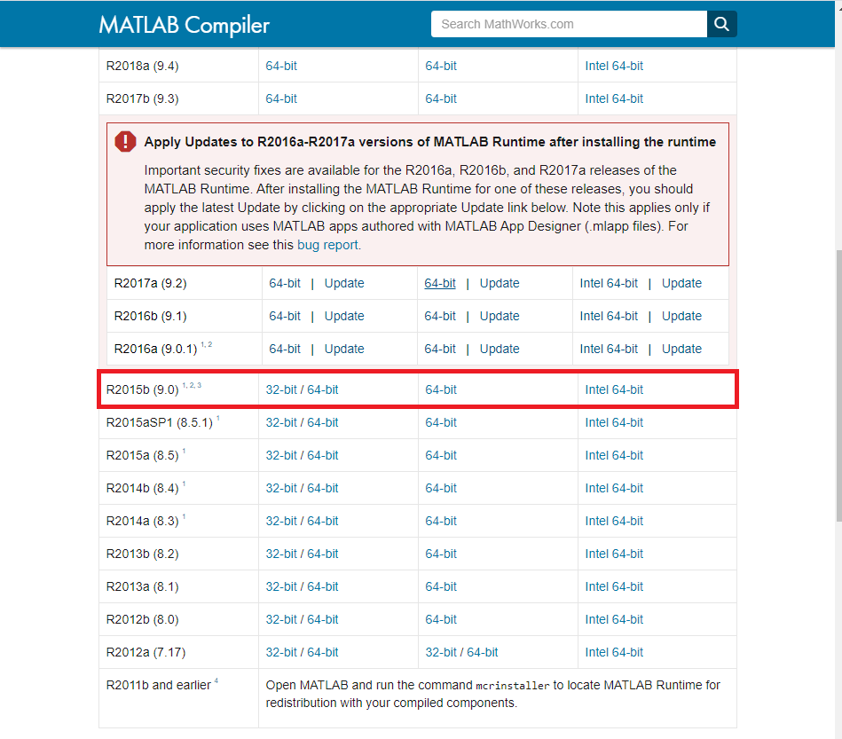

- Unzip the ctm4xas.zip and open the ctm4xas.exe and open it. The following window should open.
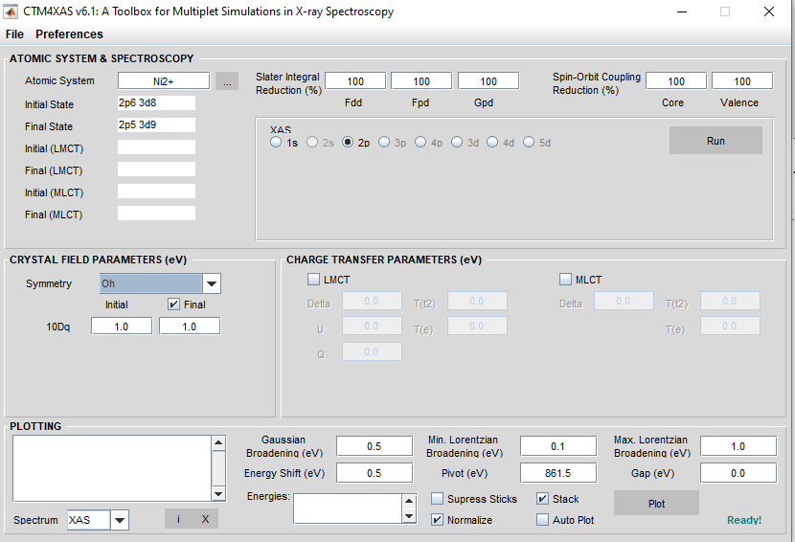

- Set the parameters that you want and press the run button to calculate the absorption spectrum of the chosen ion. In the bottom part, press the Plot button to plot the simulation. For the Ni2+ ion the result should look like this:

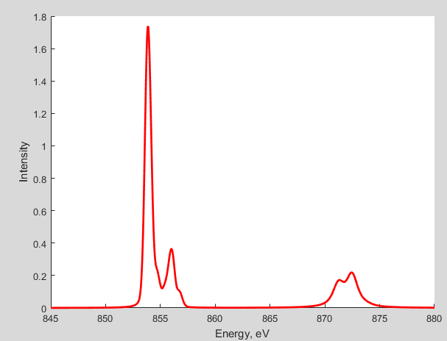
- Go to “Preferences -> Supporting program” and try to calculate XAS with both methods “Cowan” and “Quanty”.

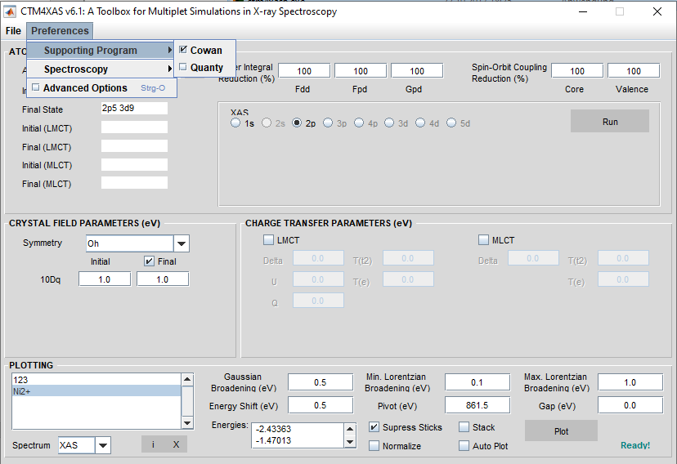
- If you want to have fun, there are some exercises here to better understand all the effects of crystal field, spin-orbit coupling, and symmetries on the XAS spectrum. https://anorg.chem.uu.nl/CTM4XAS/tutorials.html

